Math Circle Problem Set 11. Name:

Problem 11.1: Paradoxes problems

A: Perhaps one of the earliest known paradoxes is about the Greek law teacher Protagoras, who took a poor but talented student and agreed to teach him without a fee on condition that after the student completed his studies and won his first law case, he would pay Protagoras a certain sum. The student agreed to do this. Well, the student completed his studies but did not take any law cases. Some time elapsed and Protagoras sued the student for the sum. Here are the arguments they gave in court.
Student: If I win the case, then by definition, I don't have to pay. If I lose the case, then I will not yet have won my first case, and I have not contracted to pay Protagoras until after I have won my first case. So whether I win the case or lose the case, I don't have to pay.
Protagoras: If he loses the case, then by definition he has to pay me (after all, this is what the case is about). If he wins the case, then he will have won his first case, hence he has to pay me. In either case, he has to pay me.
Who was right?

B: You find a paper with a list of three sentences on it.
- This sentence has five words.
- This sentence has eight words.
- Exactly one sentence in this list is true.
Which of sentences (1), (2), and (3) are true and which are false?

Problem 11.2: Three logic puzzles
A: Hassan was a good friend of Ali and Ahmed. The following facts are true about them:
- Either Ali or Ahmed is the oldest of the three.
- Either Hassan is the oldest or Ali is the youngest.
Who is the oldest and who is the youngest?

B: A brother and sister were asked who was older. ‘I am the older,’ said the brother. ‘I am the younger,’ said the sister. It turned out that at least one of them was lying. Who is older?

C: A man was being tried for having robbed a caravan. Three witnesses came forth and made the following statements:
First Witness: The defendant has committed over a dozen robberies in the past!
Second Witness: That is not true!
Third Witness: He has certainly committed at least one robbery!
As it turned out, only one of the witnesses had told the truth. Did the defendant rob the caravan or didn’t he?

Problem 11.3: Adding shapes problems
Using graph paper, come up with a cool shape, break it apart into two subsets, and challenge a friend to put them back together.

Can you make a symmetric shape out of two non-symmetric shapes?

Problem 11.4: Billiards drawing
Draw the path starting in the lower left corner on 1x5, 2x5, 3x5, 4x5, 5x5, 6x5 shapes. What pattern do you see about what corner the ball stops in? What corner do you think the ball will stop in if we drew a 97x5 shape?

Problem 11.5: Another drawing problem
Now we’re going to draw the billiard table with a shape that isn’t a rectangle. Where does the path go if we draw it on this ‘plus’ shape?
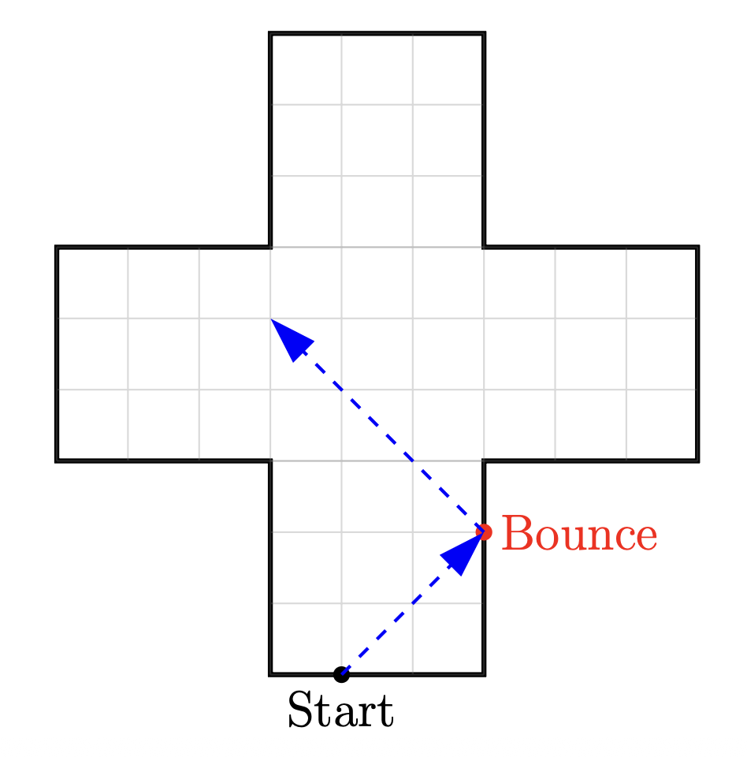
What happens if we change the size of the plus shape? Try it with 4x4 blocks, and with 2x3 arms.

